SMART MIRROR

**Description: -** A smart mirror, also known as a magic mirror, displays the time, weather, calendar, news, and social media updates. The magic is created by placing a transparent mirror over a screen such as a tablet, monitor, or TV. The technology is driven by a Raspberry Pi or combined Windows PC, with voice recognition and touch technology.

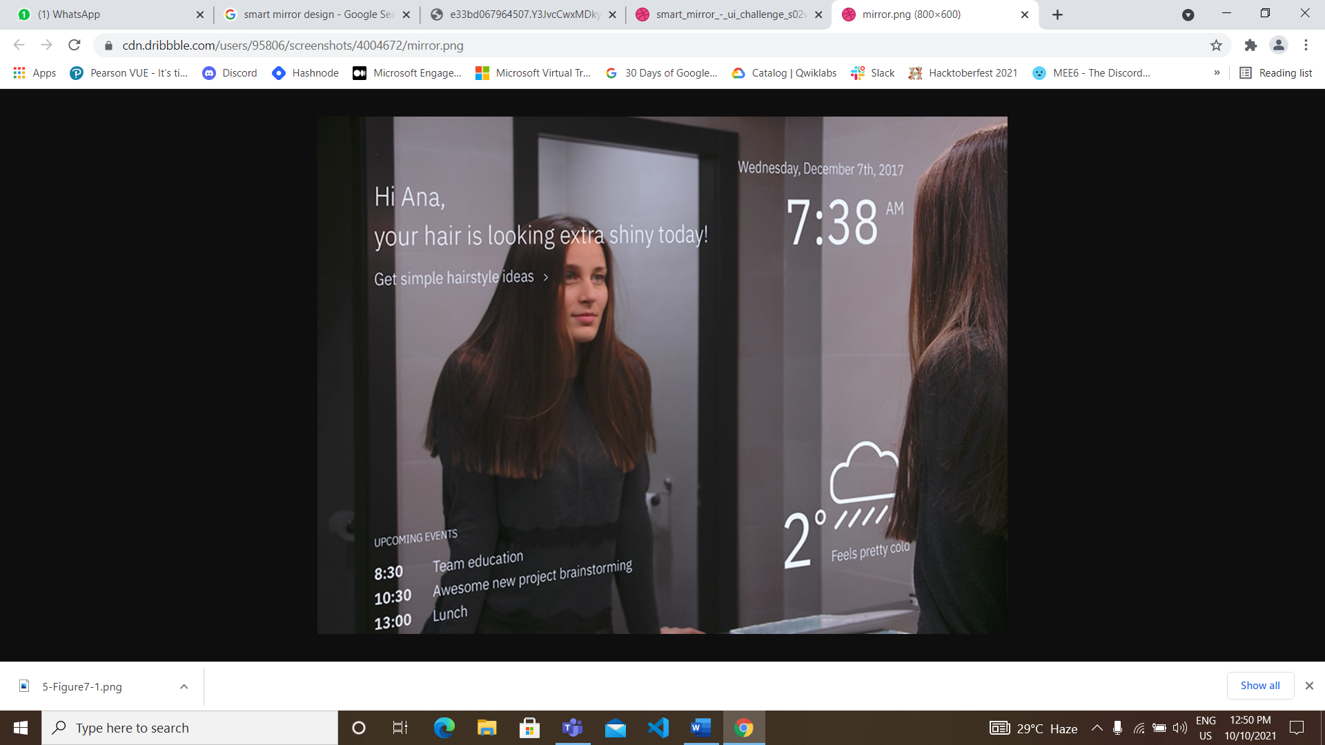

|  |  |
| --- | --- |
| **Components-Required** | **Cost** |
| Raspberry pi 4 module | 5000/- |
| Pi 4 case | 250/- |
| Pi 4 adapter | 750/- |
| LED monitor | 10000/- |
| Two-way mirror | 2000/- |
| SD card (32 GB) | 400/- |
| HDMI cable | 200/- |
| Speaker | 500/- |
| Microphone | 200/- |
| LED lights | 400/- |
| PLY | 500/- |

**MATERIAL**

**TOTAL Cost: 20,200/- INR**

**: Procedure :**

Step:1 **Frame Design**

First things First, we need to make the frame of the smart mirror**.**

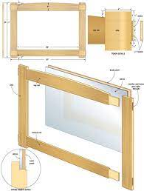

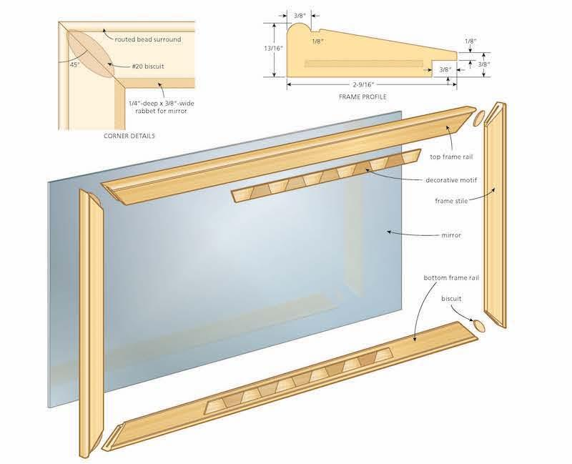

Step:2 Installation

We need to install few software’s and module to obtain the desired result facilities we need as our output in the smart mirror.

1. **Install Raspberry Pi OS**
2. **Install Magic Mirror**
3. **install modules**
4. **Magic Mirror Auto Start**
5. **Raspberry Pi auto restart**

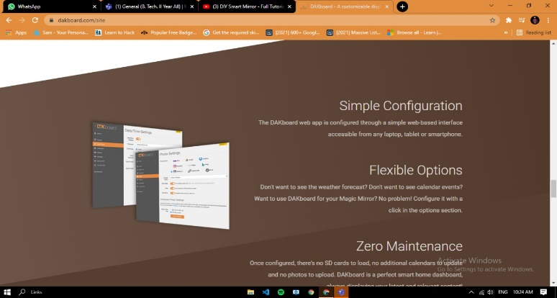 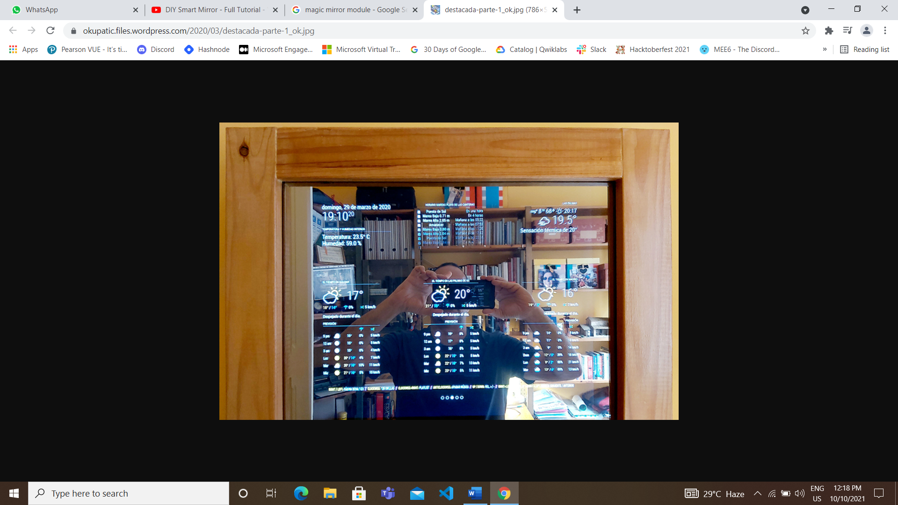 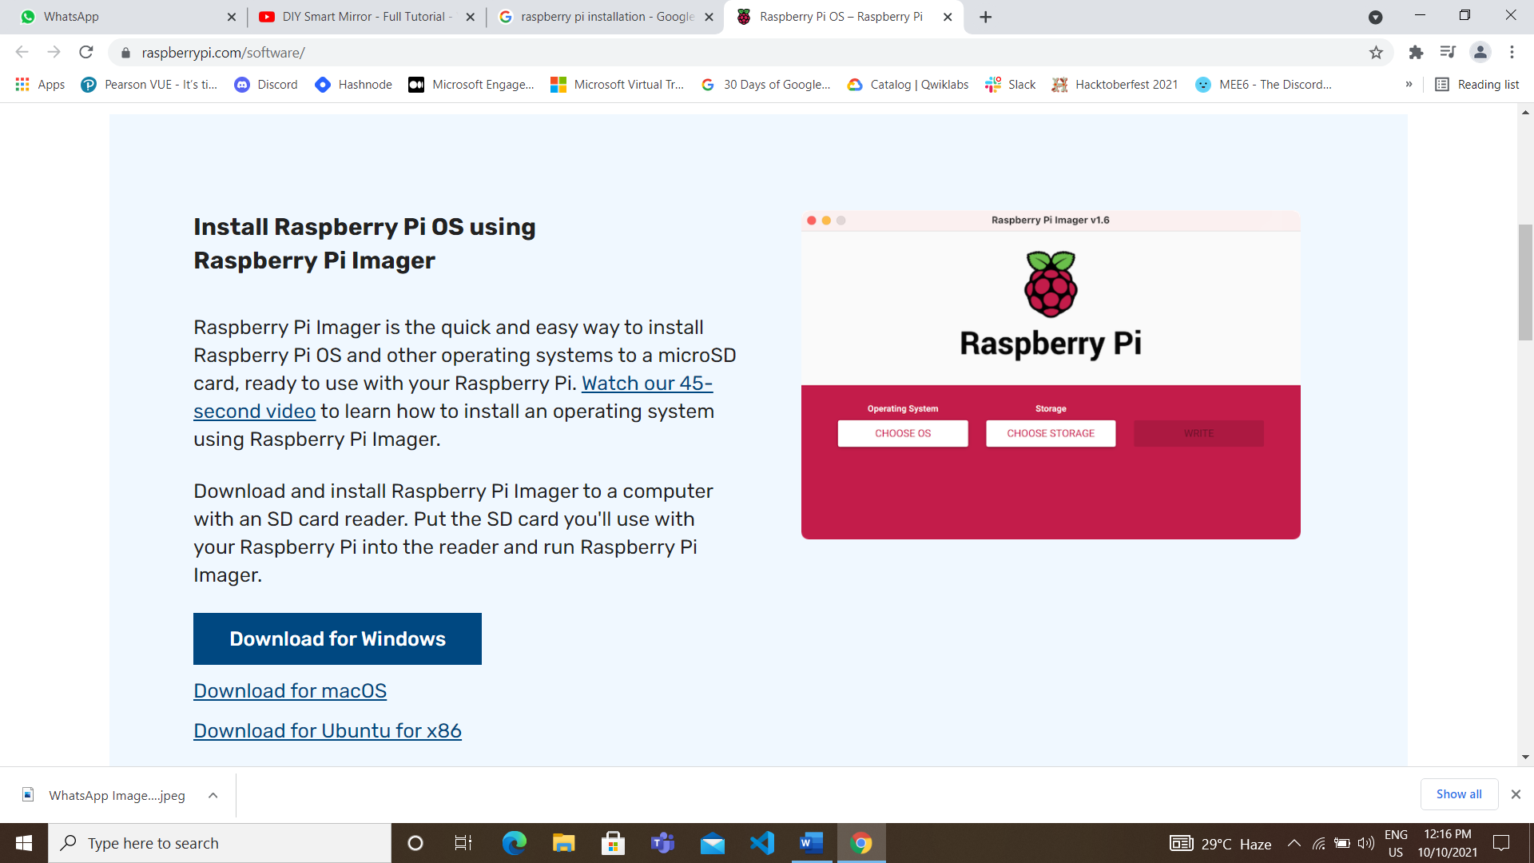 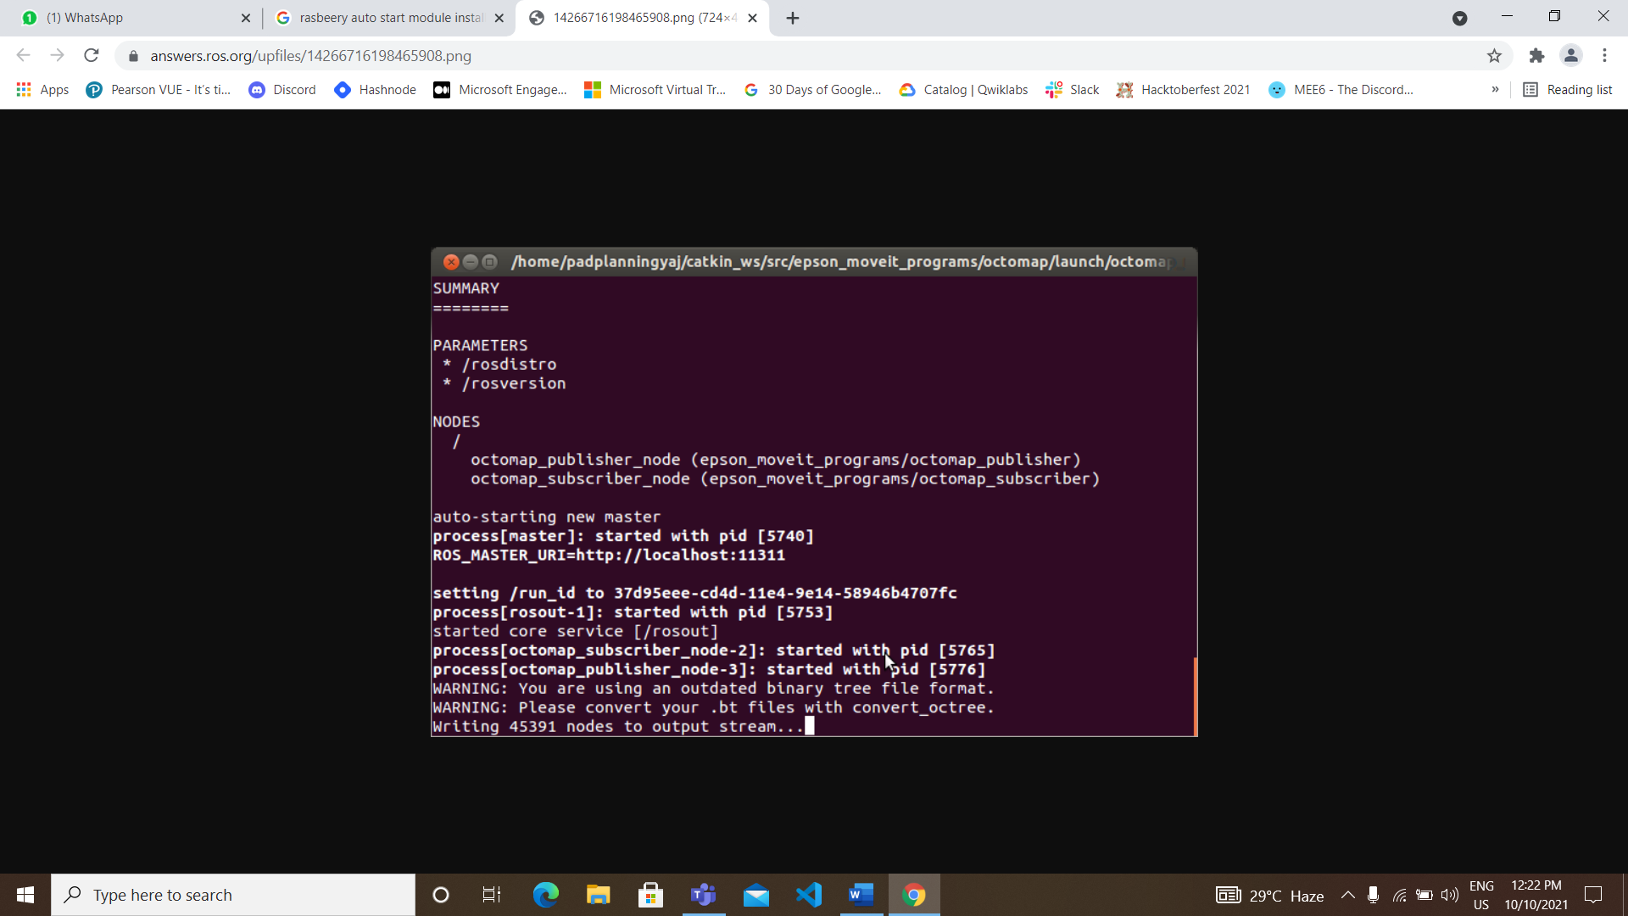

Step:3 **INTEGRATION**

NOW it’s the time to integrate all the components, in the previous steps we are done with the frame and software installed raspberry pi. Now we have to integrate the following into the frame: -

>monitor screen

>two-way mirror

>raspberry pi

>led light

The rest work is of connections. Now, Connection needs to be done carefully and the connection should be more Clean and well connected.

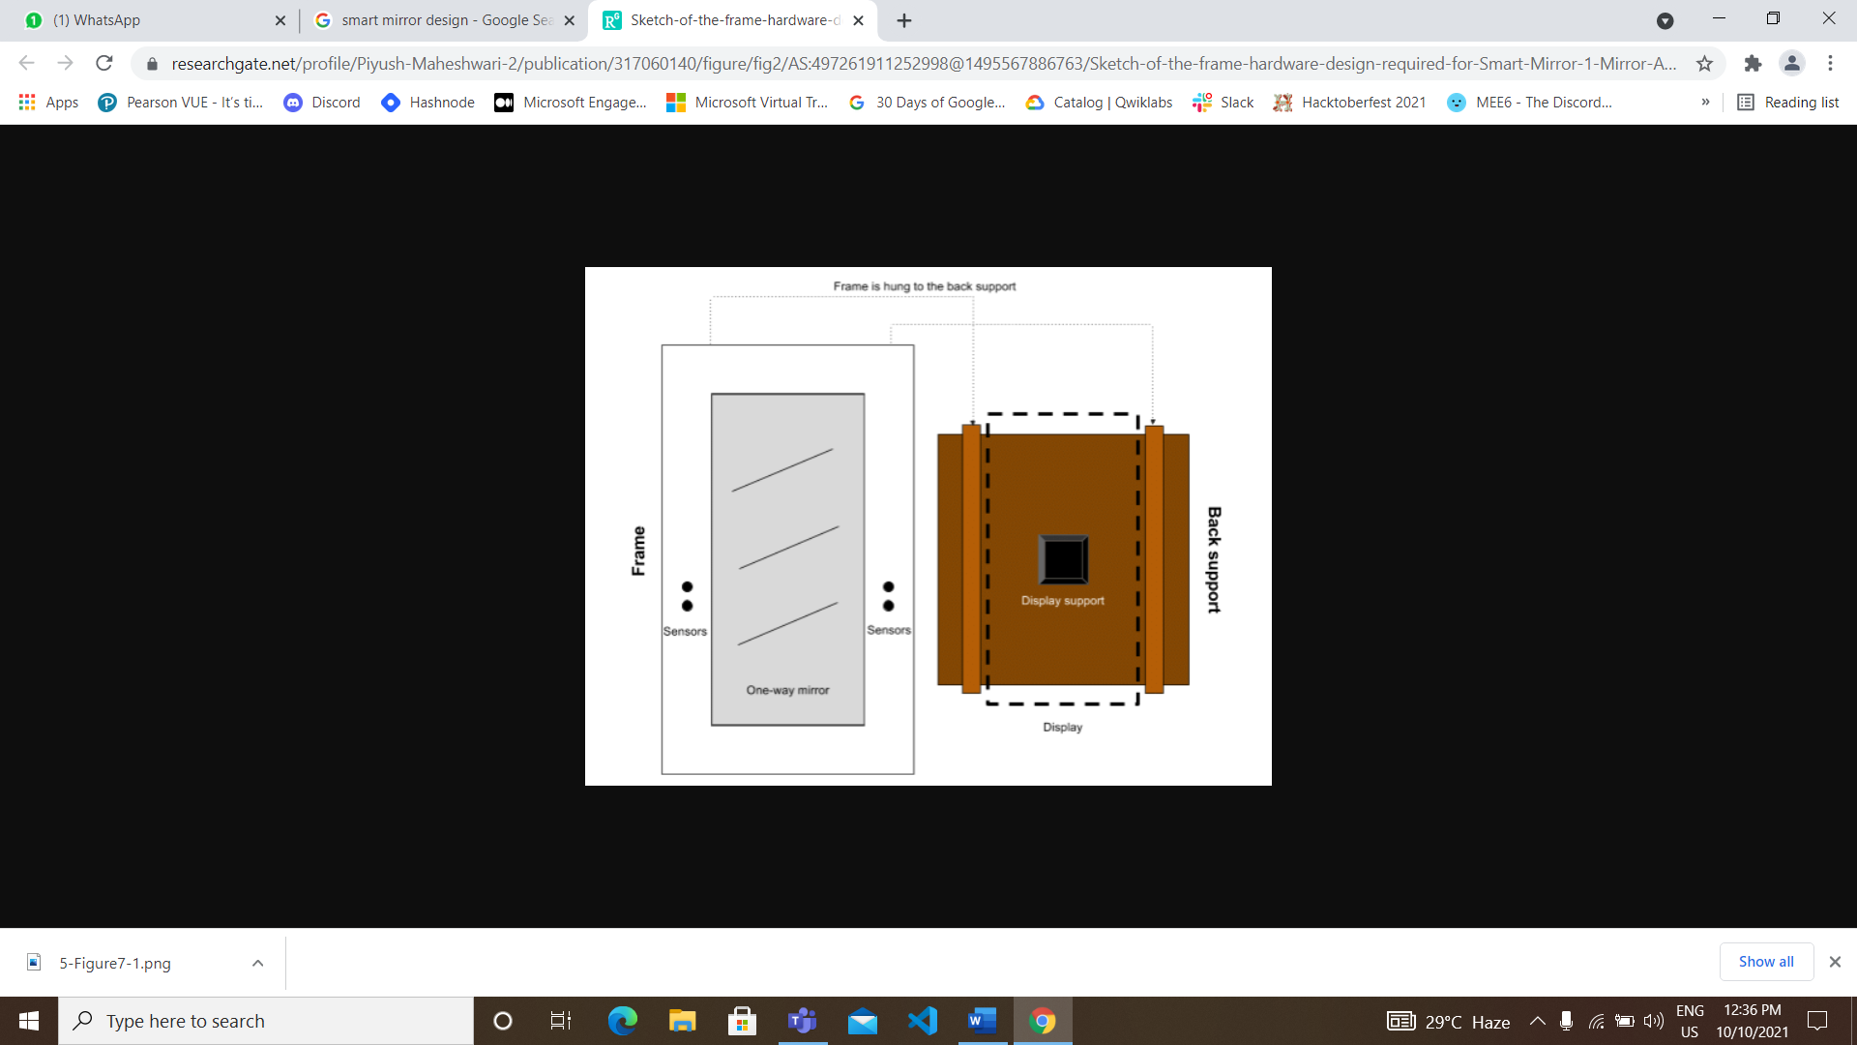

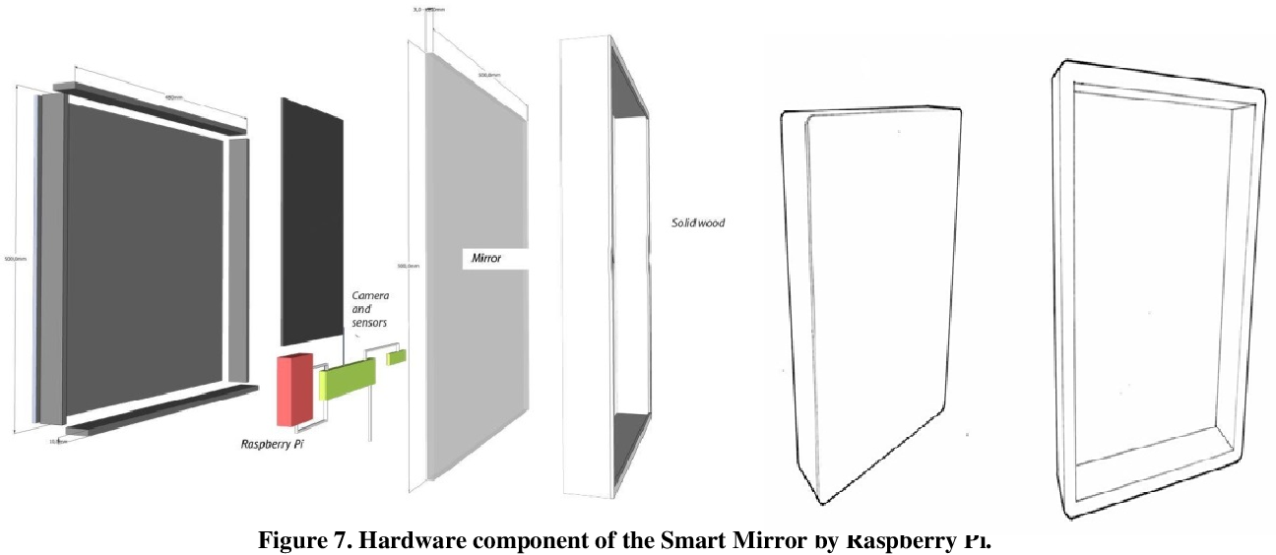

Step:4 Final Outlook

Hurray!!!!!!

This is the final outlook of the project.

In this we will get our reflection with the digital updation of various feature in the mirror itself.



MORE OUTLOOK …

